Starting in the top left corner of a 22 grid, there are 6 routes (without backtracking) to the bottom right corner.
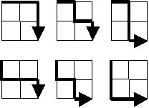
How many routes are there through a 2020 grid?

